# http://scn.sap.com/community/image/2487/1.png?a=340011CISSA: SAP Lumira Workshop

# Lab Notes

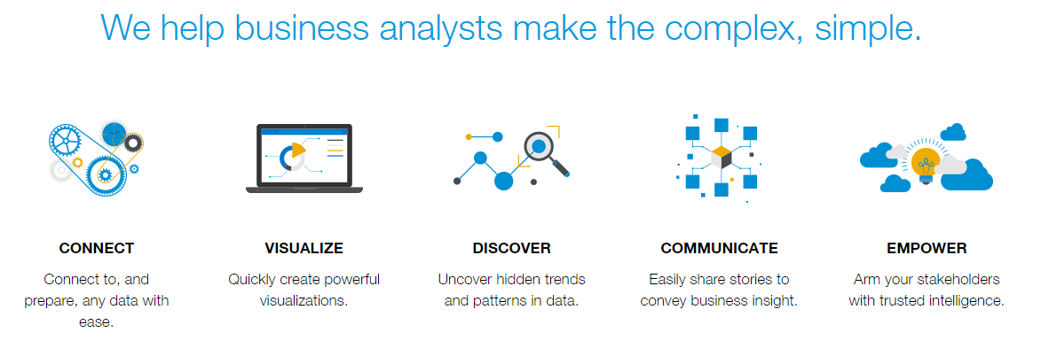

Adapted from:

Mr Lum Eng Kit | [eklum@smu.edu.sg](mailto:eklum@smu.edu.sg)

Prof Venky Shankararaman | [venky@smu.edu.sg](mailto:venky@smu.edu.sg)

*School of Information Systems,*

*Singapore Management University, Singapore*

Contents

1. Installation 3

1.1 How to identify 64bit or 32bit? 3

2. Choosing a chart type for data 4

3. Case Study 1: Best Run Corp Retail 5

3.1 Get Started 5

3.2 Create a visualization to display the sales revenue by year-quarter. 7

3.3 Create a visualization to display the sales revenue and gross margin by year and quarter. 10

3.4 Create a visualization to display the sales revenue by countries in year 2012 13

3.5 Create a visualization to display the cumulative gross margin for all countries in year 2012 18

4. Case Study 2: Summer Olympics 21

4.1 Get Started 21

4.2 Create visualization to display Medal by Country and Medal 23

4.3 Create visualization to display Medal by Country in 2012 25

4.4 Create visualization to display the country that won the most gold medals 26

4.5 Create visualizations to display Bronze, Silver, Gold by Top 10 Countries in 2012 29

4.6 Create visualizations to display Medal by Top 10 Countries and Year 30

4.7 Create visualizations to display the total amount of winners in gender by years 31

4.8 Create visualizations to display Medal by Aquatics & Athletics by Top 10 Countries 31

4.9 Create visualizations to display Medal by Athlete 32

4.10 Adding visualizations into infographic 35

5. Case Study 3: Household Electricity 37

5.1 Compose story of Household Electricity Consumption by dwelling type 37

6. Appendix: Working with the Electricity Consumption Data 41

7. Resources 45

7.1 Dataset Links 45

7.2 SAP Lumira Help Links 45

7.3 Sample of Challenge 45

# 1. Installation

Prerequisites:

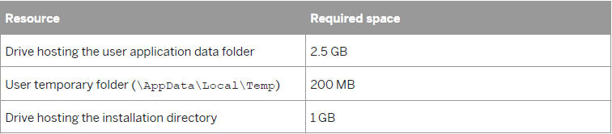

Download the installation package from <http://www.saplumira.com/download/>.

Double click the **SAPLumirainstall.EXE file** to install the software.

### 1.1 How to identify 64bit or 32bit?

1. Go to **Control Panel > Systems and Security > System**

2. If you don't see that option, on the top right hand corner, select “Small icons” or “Large icons” under “View by”

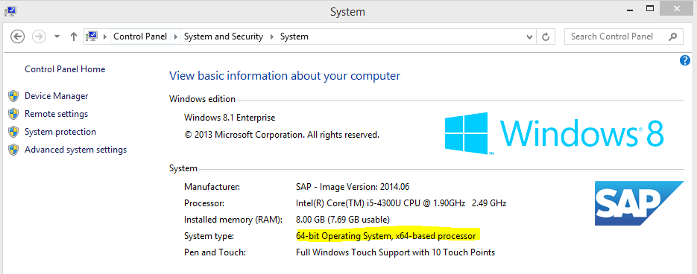

# 2. Choosing a chart type for data

|  |  |  |
| --- | --- | --- |
| If you want to see differences  in your data by | For example | Choose one of these |
| *Comparison* | You want to view the differences between values or need to show a simple comparison of categorical divisions of measures. You could use a bar chart to compare the differences in your sales revenue between different countries. | * *Vertical bar chart* * *Horizontal bar chart* * *Stacked column or bar chart* * *Bar chart with two X or Y axes* * *3-dimensional column chart* * *Radar chart* * *Tag cloud chart* * *Funnel chart* * *Table* |
| *Percentage* | You want to show the percentage of parts to a whole or show values as ratios to a whole. The legend shows the percentage and the total values. For example, use a pie chart to see who had the highest sales as part of a total sales value directly:  Total sales = $200, Paul had 10% ($20),  David had 65% ($130), and Susan had  25% ($50) | * *Pie chart* * *Donut chart* * *Pie with depth chart* * *Treemap* |
| *Correlation* | You want to view the relationship between values or to compare multiple measure values. For example, you can view the correlation of two measures and understand the impact of the first measure on the second measure. | * *Scatter plot* * *Bubble chart*   *The size of the bubbles in a chart is determined by a third measure.*   * *Scatter matrix chart* * *Box plot chart* * *Network chart* * *Parallel coordinates chart* * *Tag cloud chart* * *Numeric point chart* |
| *Trend* | You want to show a trend in values, especially for dimensions that are time based, such as Year. You may also want to see the progression of your data and possible patterns. For example, you can use a line chart to view sales revenue trends for a product, for a range of years. | * *Line chart* * *Area chart* * *Line chart with two Y axes* * *Combined column chart with two Y axes* * *Waterfall chart* * *Heat map* |
| *Geographical* | You want to show a map of the country object used in the analysis. You may also need to see data for dimensions sorted by country shown on the map or want to see the geographical spread of data for one country. | * *Geographic bubble chart* * *Geo choropleth chart* * *Geo pie chart* |

# 3. Case Study 1: Best Run Corp Retail

**Best Run Corp Retail is a global company that sells apparels. The management of Best Run Corp Retail wants to analyze its sales performance and is interested in answering some of these:**

1. What were the Sales Revenues by Year and Quarter between *2009* and *2012*?
2. How did Sales Revenues compare with Gross Margins between *2009* and *2012*?
3. Which were my best performing countries in *2012*?
4. What was the cumulative gross margin for all countries in *2012*?

### 3.1 Get Started

Let’s first **acquire data** from a spreadsheet.

1. Launch SAP Lumira. On the *Home* page, click *Acquire Data*.

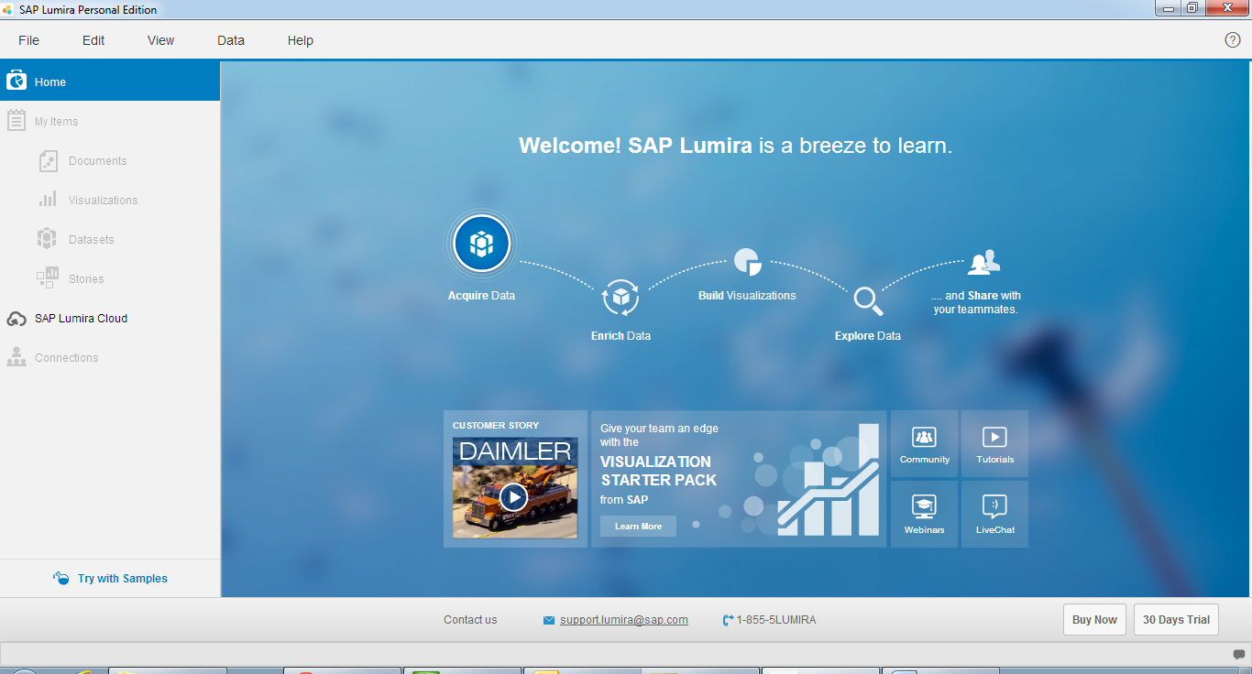

1. Double-click on *Microsoft Excel*.

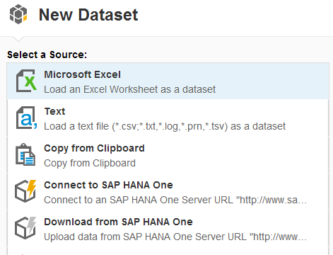

1. Download *BestRunCorp_Retail.xlsx*
2. Click *Create*.

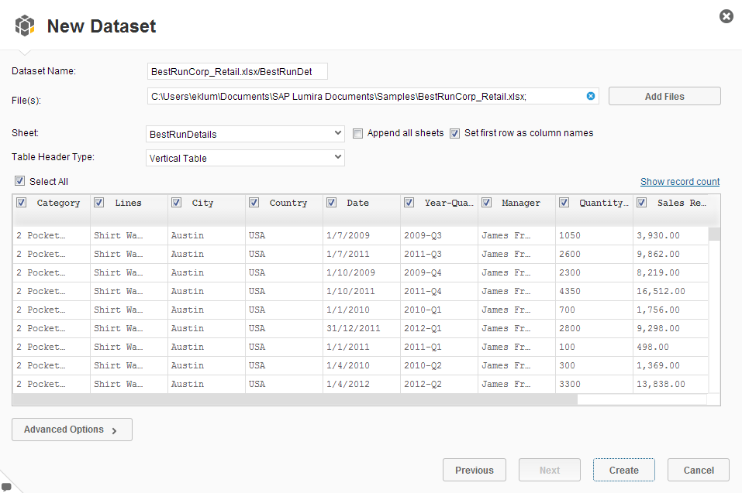

The data is loaded in SAP Lumira and the *Visualize* workspace opens. Now, we can create visualizations.

## **3.2 Create a visualization to display the sales revenue by year-quarter.**

By default, a bar chart is used.

1. Change the chart type to *Column Chart* by choosing it from the *Bar & Column Charts* choice of charts.

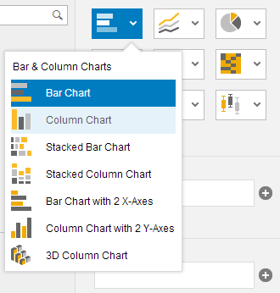

1. Double-click *Sales Revenue* in *MEASURES* to add a measure (Y-Axis) and double-click *Year-Quarter* in *DIMENSIONS* to add a dimension (X-Axis).

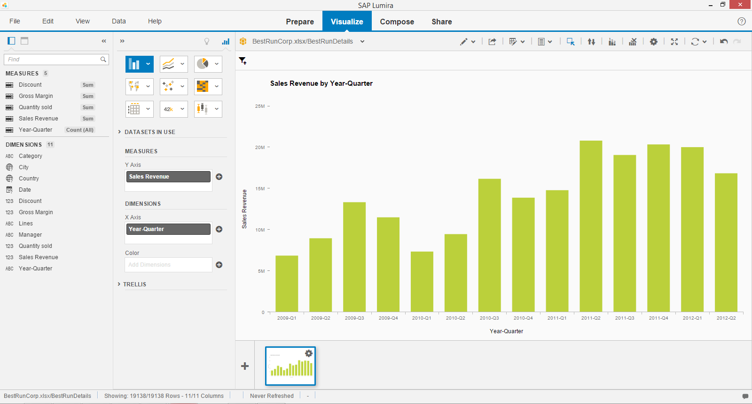

Let’s group them by Year & Quarter. There is neither a Year nor Quarter field in the data (spreadsheet) but we can edit the data set after it has been acquired.

1. Switch to the ***Prepare*** workspace to edit the dataset.

The Year-Quarter column contains the Year & Quarter information separated by a dash (-). We can use the manipulation tools to create individual Year & Quarter columns by splitting the existing column.

1. Select the *Year-Quarter* column.



1. In *DATA ACTIONS*, select *Split*.

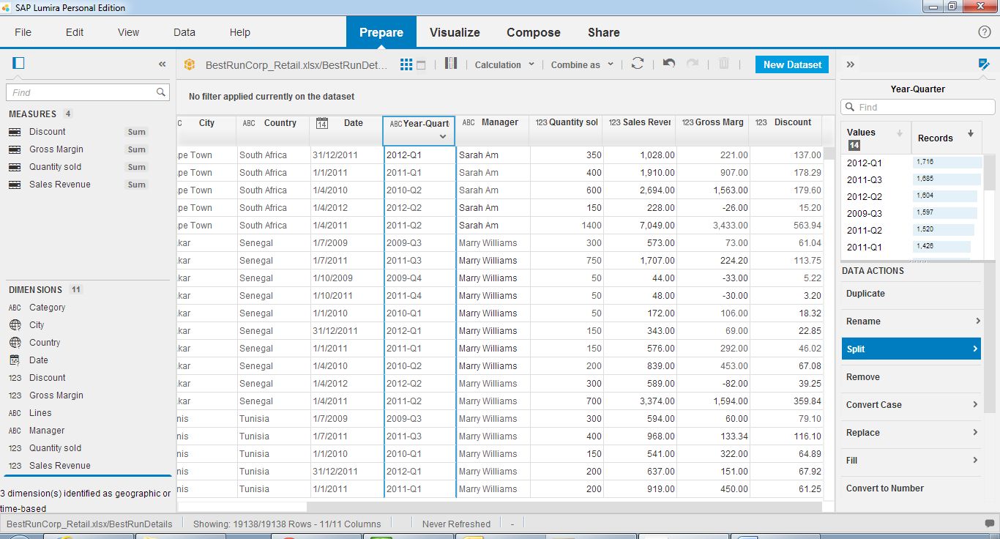

1. Enter **-** for *Split on* and click *Apply.*

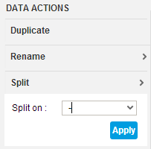

2 new columns should be created to contain the split data.

Rename the columns. Select the pull-down menu in the column header and choose *Rename*.

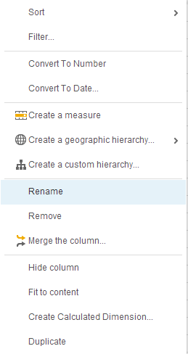

1. Rename to *Year*; do likewise for *Quarter*.

Now, we can group the Sales Revenue by Year & Quarter.

1. Switch back to the ***Visualize***workspace.
2. Remove *Year-Quarter* from the DIMENSIONS X-Axis by clicking on the x icon.

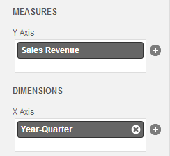

Then double-click *Quarter* in *DIMENSIONS* and drag *Year* to *TRELLIS 🡪 Columns.*

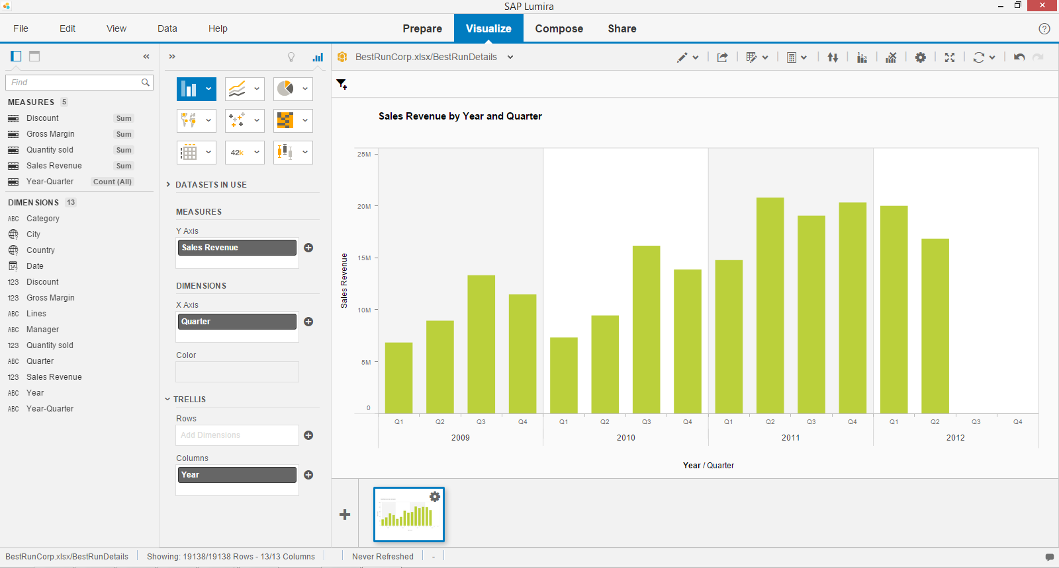

1. Save the document; select *File 🡪 Save*, enter *Retail Analysis* for *Name* and click *Save.*

Q1. What was the sales revenue for Q3 of 2011?

## **3.3 Create a visualization to display the sales revenue and gross margin by year and quarter.**

Instead of creating a new visualization from scratch, we can duplicate the one we have just created and edit it.

1. Click on the *Options* icon in the thumbnail of the 1st visualization and select Duplicate.

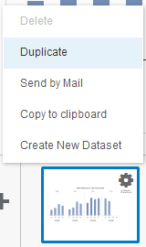

1. Select the 2nd thumbnail to switch to the duplicated visualization.
2. Double-click Gross Margin in MEASURES to add an additional measure (Y-Axis).

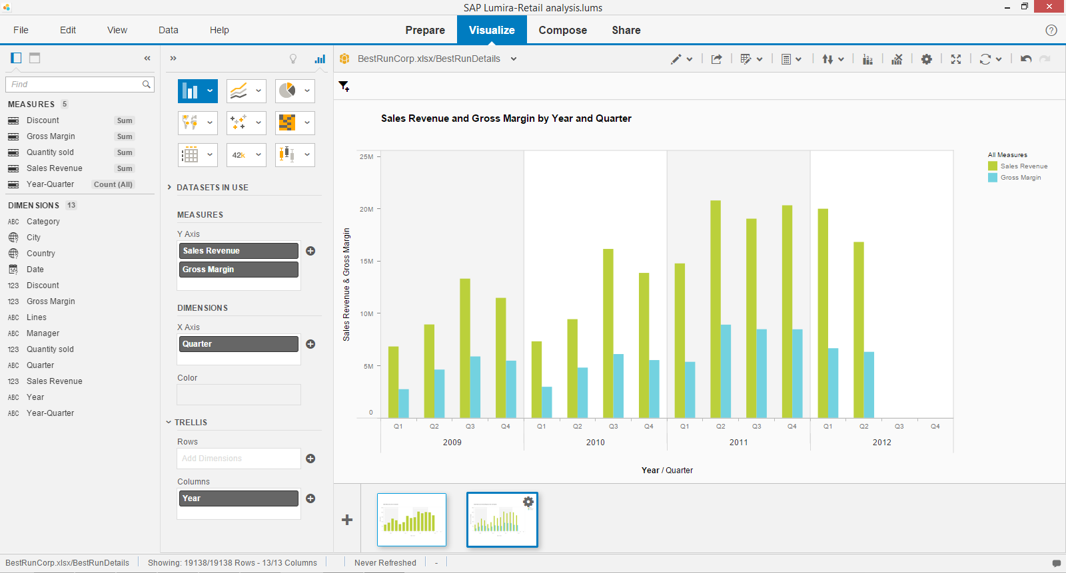

1. Change the chart type to *Line Chart* *with 2 Y-Axes* by choosing it from the *Line Charts* choice of charts.

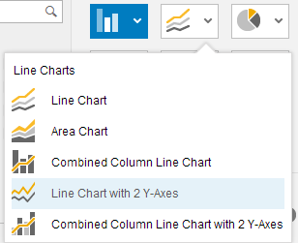

Now, you can see the Sales revenue and gross margin by year and quarter.

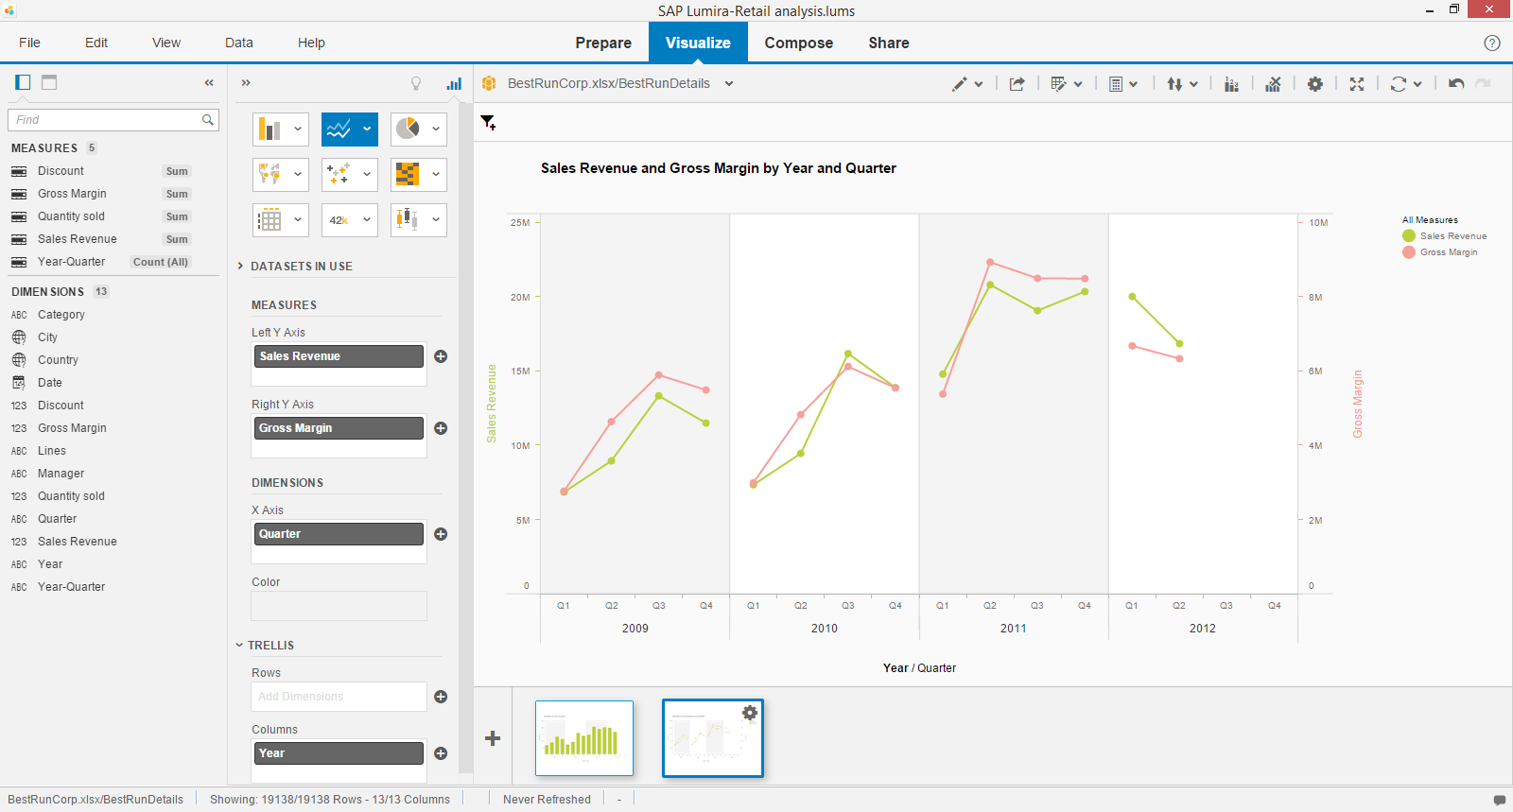

1. Save the document.

Q2. Briefly state how a *Line Chart* *with 2 Y-Axes* is used.

Q3. Is this chart suitable to compare Sales Revenue with Gross Margin? If not, what chart would you have chosen and why?

## **3.4 Create a visualization to display the sales revenue by countries in year 2012**

1. Duplicate the 2nd visualization and then switch to the duplicated visualization.
2. Remove *Quarter* and *Year* from *DIMENSIONS* and *TRELLIS* respectively by clicking the *Delete* icon.

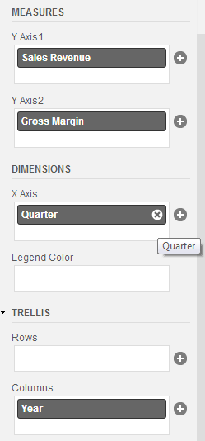

1. Also delete *Gross Margin* from *MEASURES.*
2. Double-click *Country* in *DIMENSIONS* to add a dimension (X-Axis).
3. 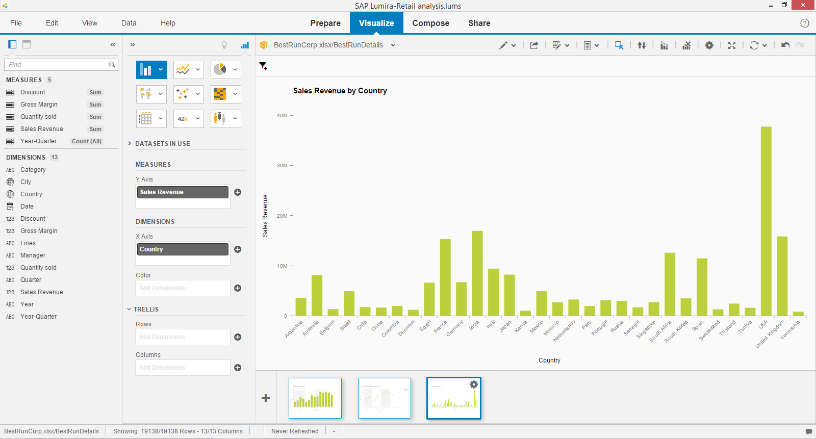Change the chart type to *Column Chart.*
4. Click *Add filters.*
5. Select *Year.*

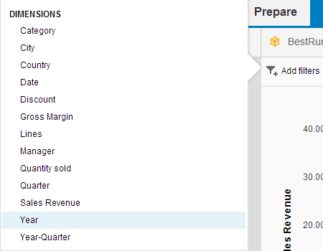

1. Choose *2012* and click *OK.*
2. Click the *Options* icon for *Sales Revenue* and select *Sort Descending.*

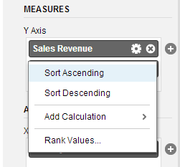

Now, you can see your best countries in terms of Sales Revenue in year *2012*. 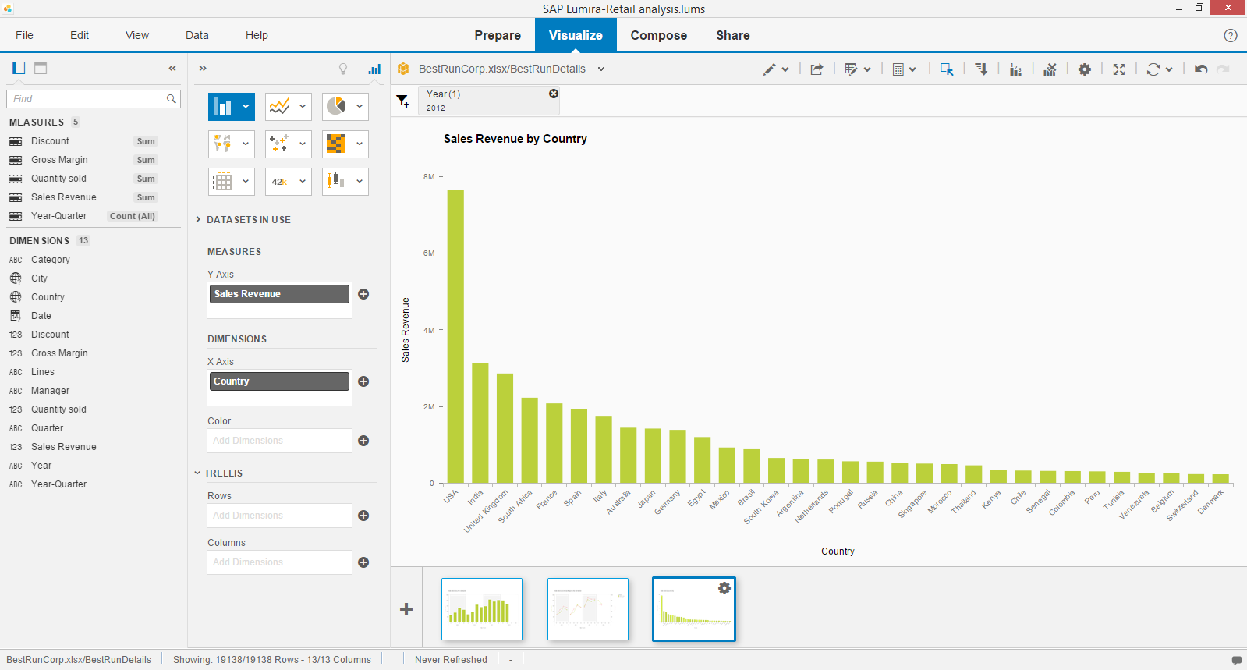

1. Change the chart type to *Geo Choropleth Chart*.

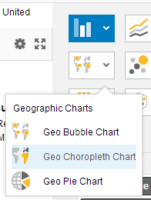

Add *Country* as a geography dimension; click the *Options* icon beside *Country* and select *Create a geographic hierarchy…* *🡪* *By Names*.

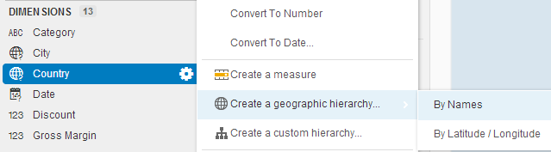

1. Select *Country* for Country:and *City* for City: and click *Confirm*.

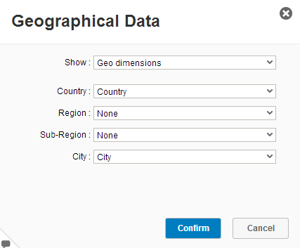

1. Click *Done.*

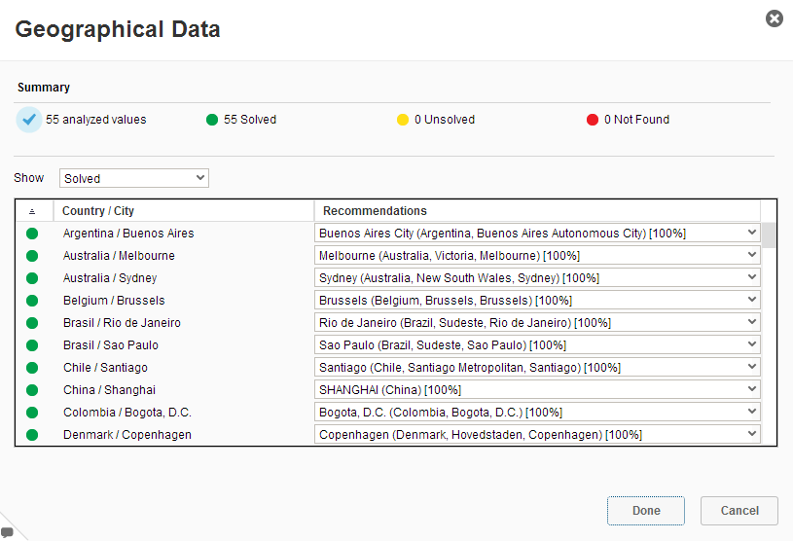

1. Double-click *Country (Country Level)* to add *Country* as a geography dimension.

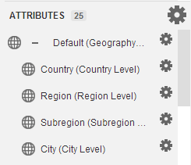 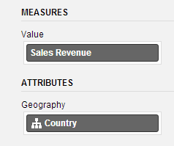

Now, you can see your best countries in terms of Sales Revenue in year *2012* on a map. 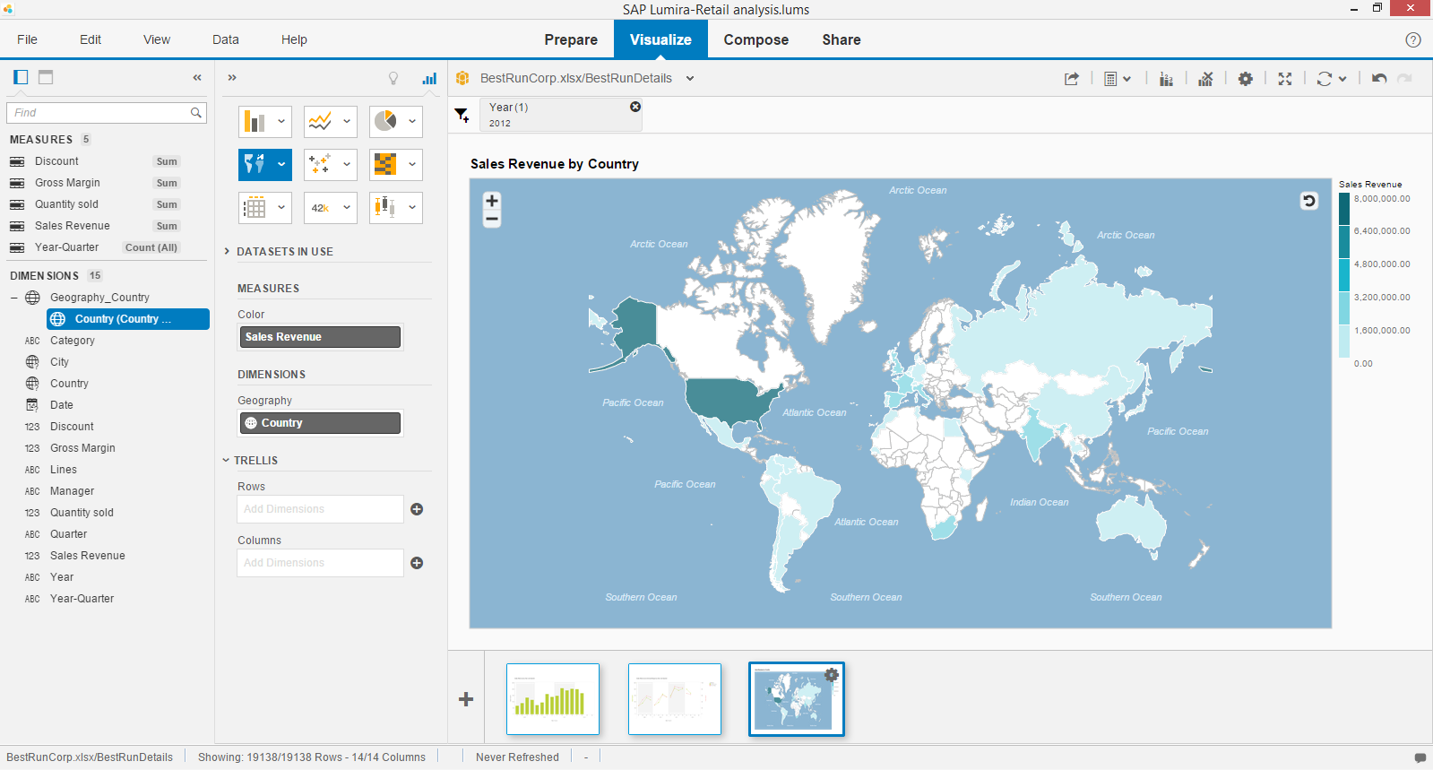

1. Change the chart type to *Geo Bubble Chart.*

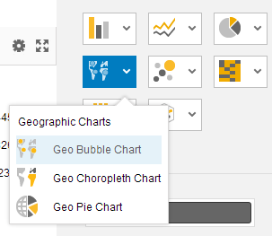

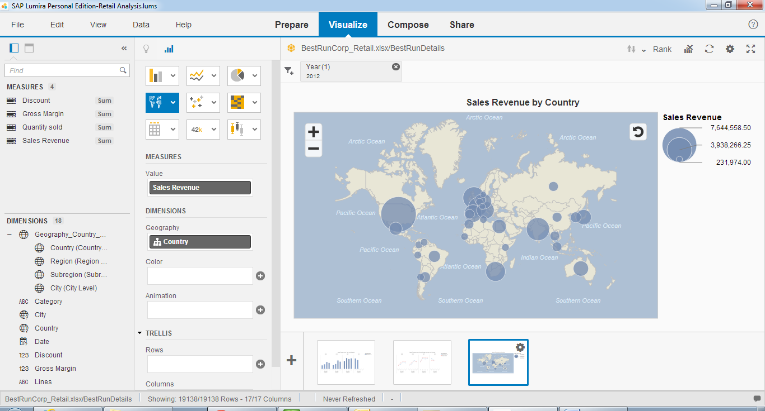

Q4. Briefly discuss which one is a better chart to display the best countries for sales revenue. (You may also suggest any other charts than these 2).

1. Save the document.

## **3.5 Create a visualization to display the cumulative gross margin for all countries in year 2012**

1. Create a new visualization by clicking .
2. Double-click on *Gross Margin* and *Country* to create a chart that displays *Gross Margin by Countries*.
3. Change the chart type to *Line Chart*.

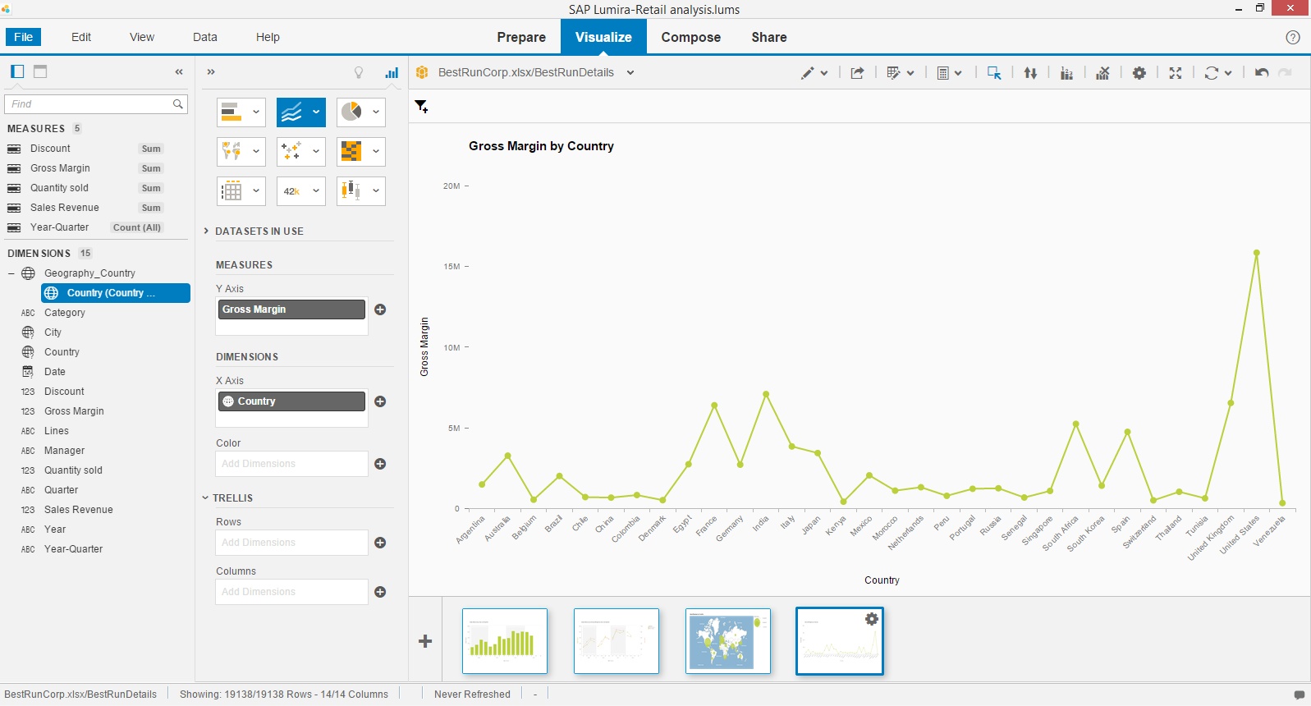

1. Add a filter for *Year*; select *2012*.
2. Click on the *Options* icon for *Gross Margin* and select *Add Calculation* 🡪 *Running Sum*.

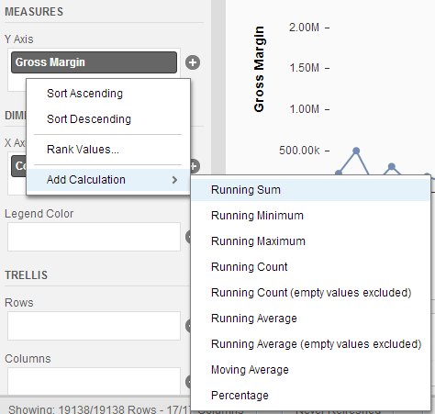

Now, you can see the gross and cumulative margins for all countries in 2012.

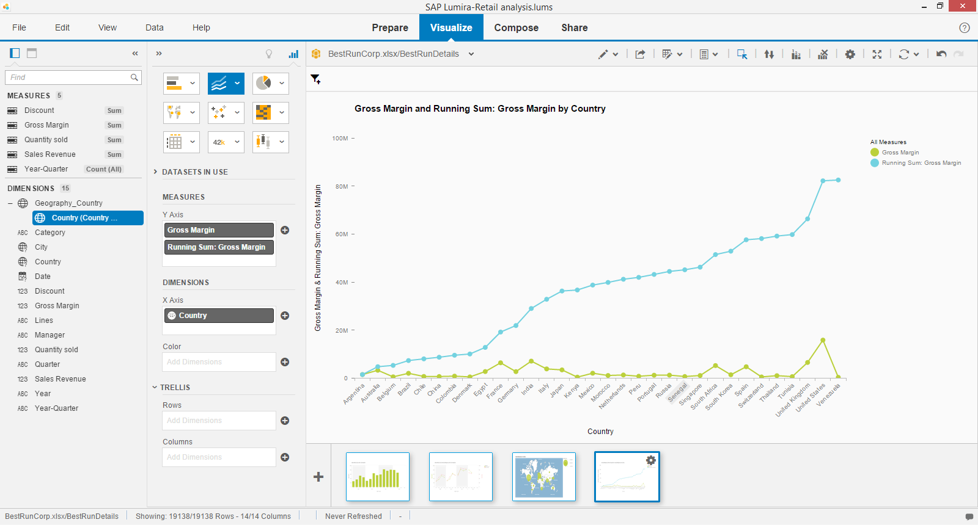

1. Save the document.

Q5. From your observation, what is a running sum of gross margin? (Give an example to help your explanation)

1. Close the document when you are done.

# 4. Case Study 2: Summer Olympics

**The Summer Olympics has grown from a 42-event competition with athletes from 14 nations to a 300-event sporting celebration with over 10,000 competitors from 205 nations.**

**Analyze the performance of the participating nations by gender and sports over the last 5 Olympics by answering some of these questions:**

1. Which are the top 5 countries in Olympics 2012 – by total number of medals won?
2. Compare the performance of China and Australia over the last 5 Olympics.
3. What are the numbers of winners by gender over the last 5 Olympics?
4. How did France fare in the sport of Aquatics and Athletics in 2008?
5. In which year(s) did Michael Phelps participate in and how many medals did he win?

## **4.1 Get Started**

Let’s first acquire data from a spreadsheet.

1. **Launch SAP Lumira.** On the Home page, click *Acquire Data*.
2. Import Data. Double-click on *Microsoft Excel*.



1. Download *Olympic Data 1996 - 2012.xlsx*
2. Click *Create*.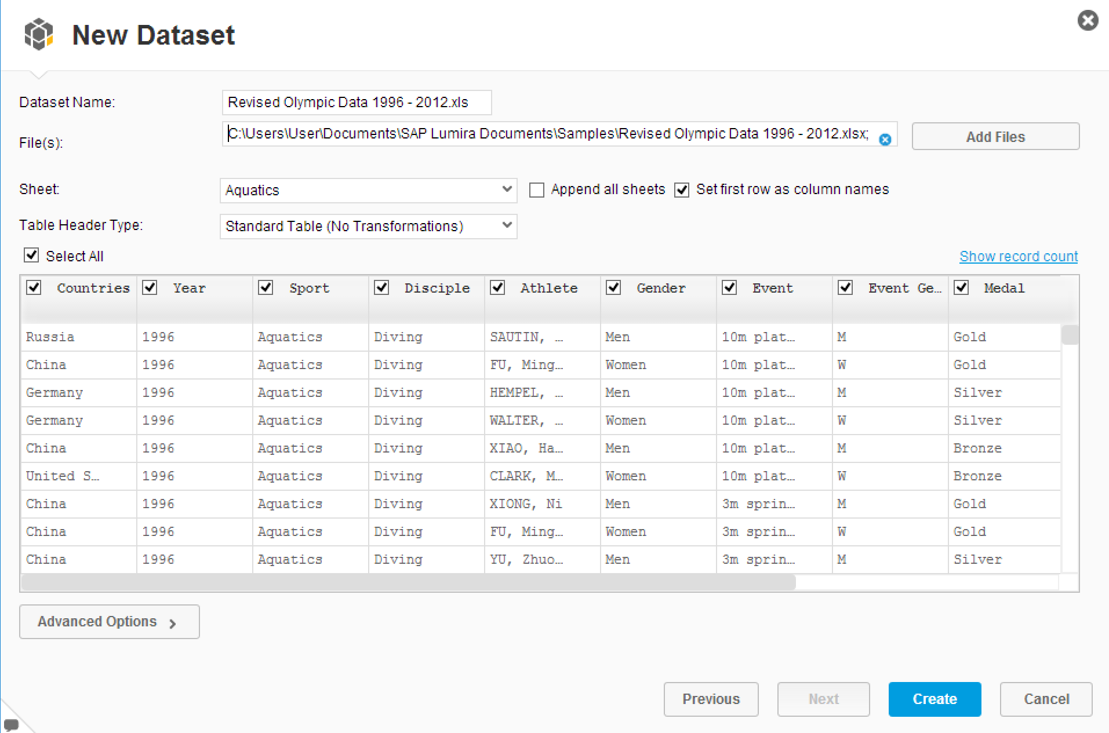

The data is loaded in SAP Lumira and the *Visualize* workspace opens. Now, we can create visualizations.

### Create visualization to display Medal by Country and Medal

1. 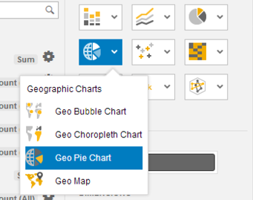Change the chart type to *Geo Pie Chart* by choosing it from the *Geographic Charts* choice of charts.

1. Add *Country* as a geography dimension; click the *Options* icon beside *Country* and select *Create a geographic hierarchy* *🡪* *By Names*.



1. Select *Country* for Country and click *Confirm*.

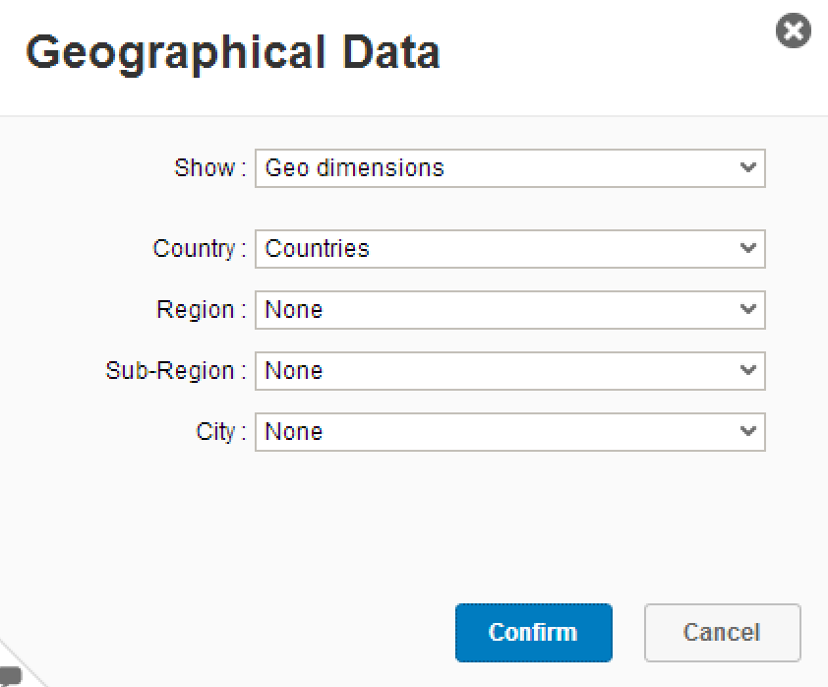

1. Click *Done.*

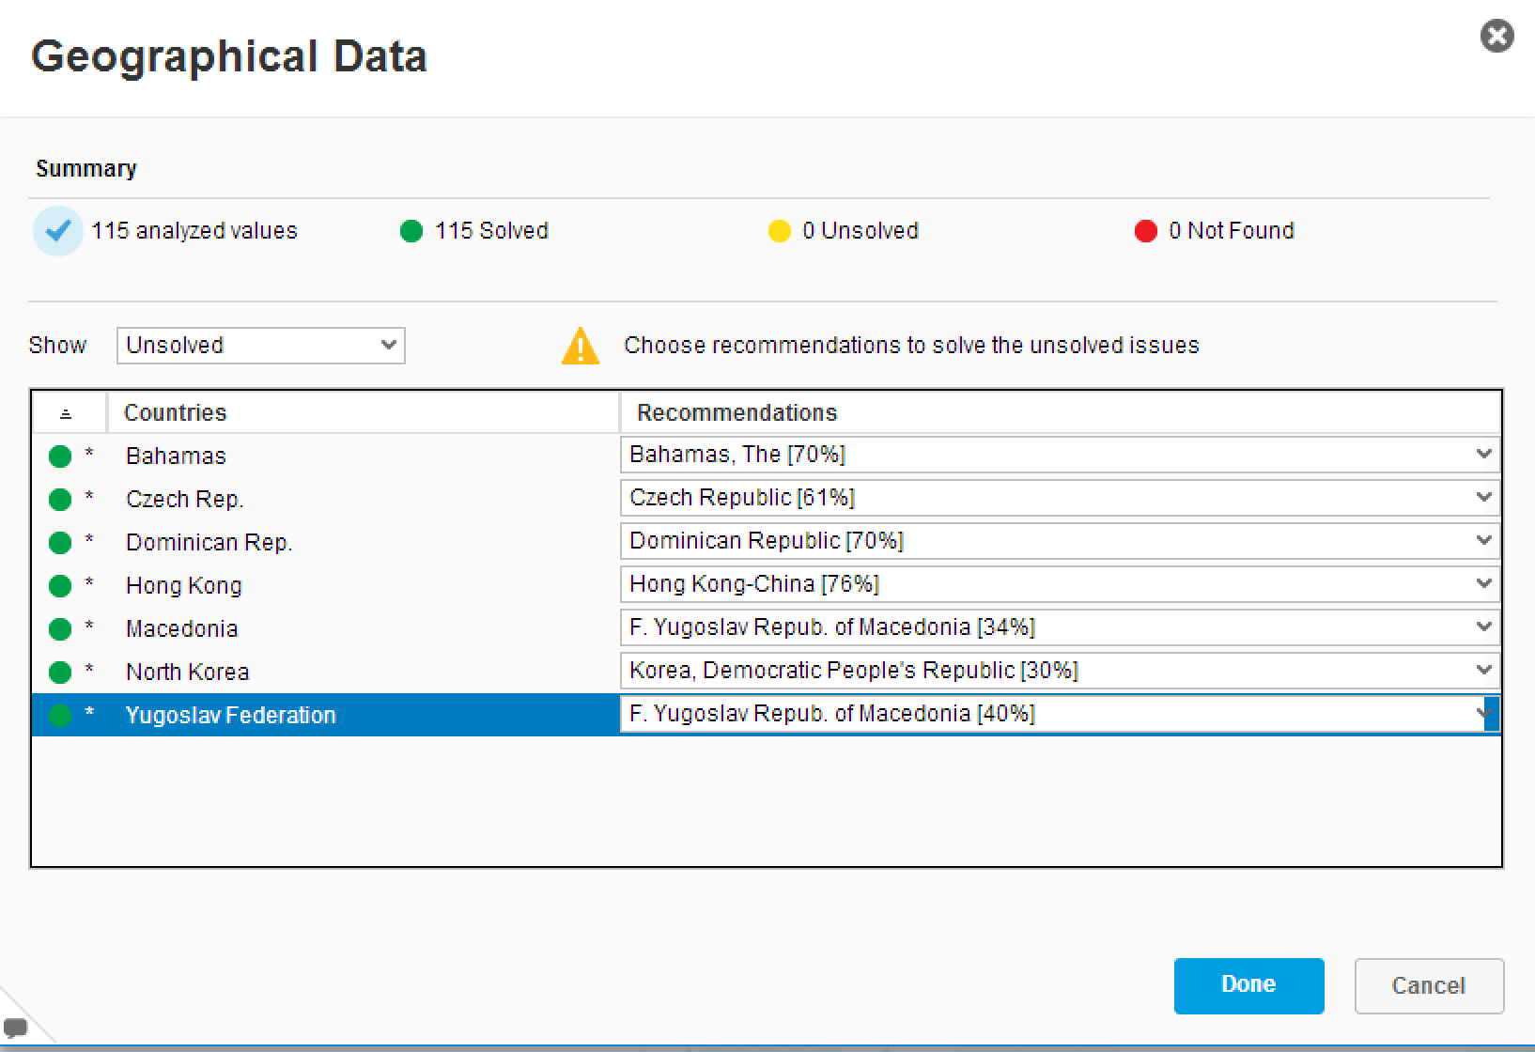

1. Convert Medal into a MEASURE
2. Double-click *Medal* in *MEASURES* to add a measure (Value) and double-click *Country in* *DIMENSIONS* to add a dimension (Geography) and double-click *Medal* in *DIMENSIONS to* add a dimension (Overlay Data).

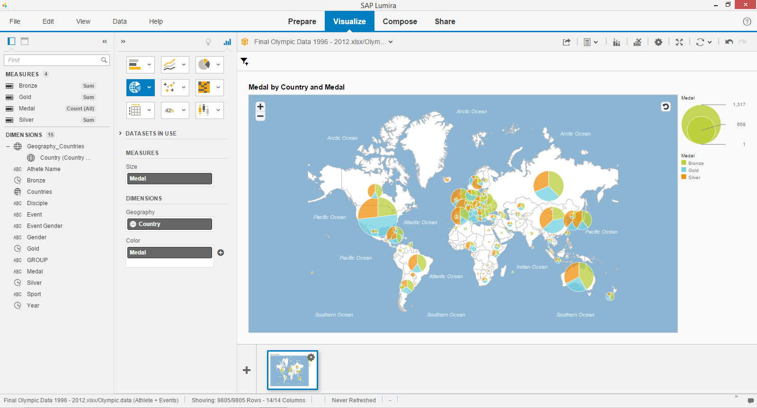

1. You may want to *filter* by year. Select add *filters* and select *year*.

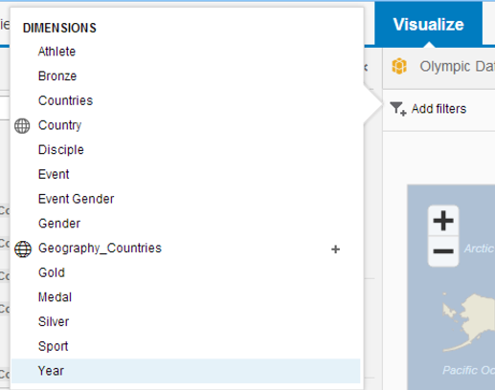

1. Choose *2012* and click *OK.*

Now, you can see countries in terms of Medal by Country and Medal in year 2012 on a map.

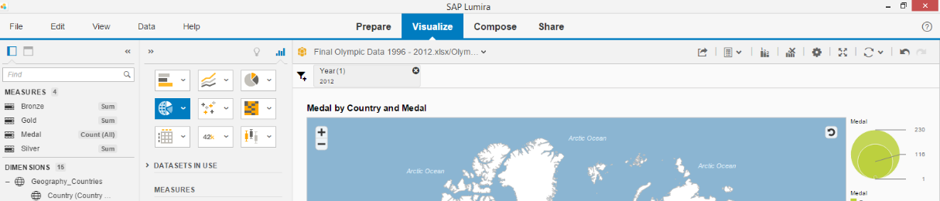

### 4.3 Create visualization to display Medal by Country in 2012

***Next, let’s create a visualization to display the medal by country in 2012***

1. Create a new visualization by clicking.
2. Change the chart type to *Geo Choropleth Chart.*
3. Double click on Medal and Country to create a chart to *display the medal by country in 2012* by adding a filter

Now you can see the medals won by country in 2012 on a map.

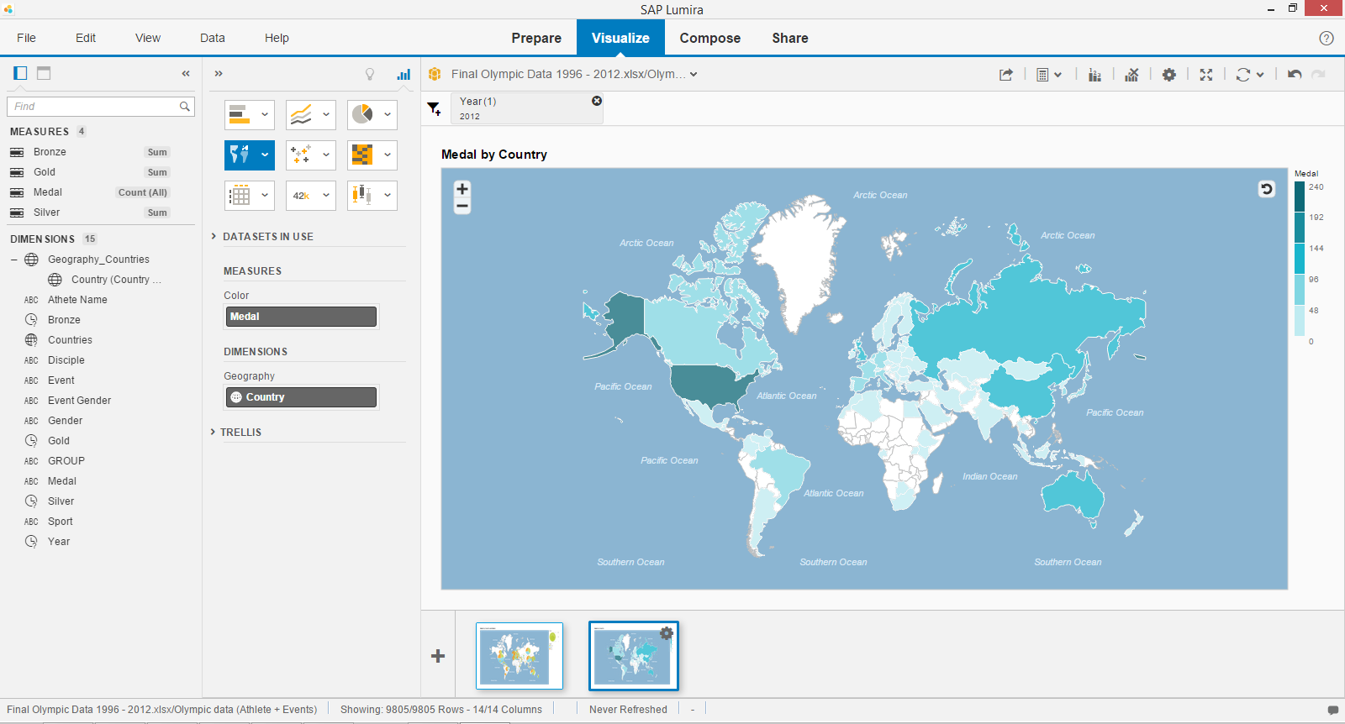

1. Save the document.

### 

### Create visualization to display the country that won the most gold medals

***Next, let’s create a visualization to display the country that won the most gold medals.***

Instead of creating a new visualization from scratch, we can duplicate the one we have just created and edit it.

1. Click on the *Options* icon in the thumbnail of the visualization (Medal by Country) and select Duplicate.

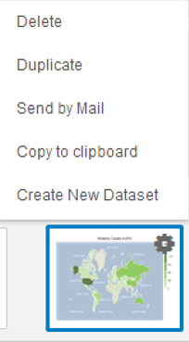

1. Select the 2nd thumbnail to switch to the duplicated visualization.
2. Change the chart type to *Tag Cloud* by choosing it from the *Other Charts* choice of charts.

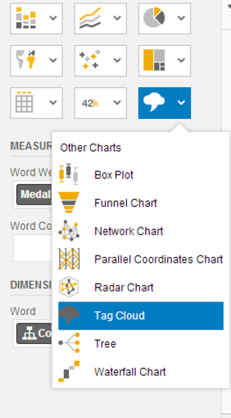

1. Double-click *Gold* in *MEASURES* to add an additional measure to Word Color.
2. Remove *Country* in *DIMENSIONS* by clicking the *delete* icon.

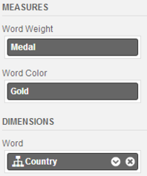

1. Double-click *Countries* in *DIMENSIONS* to add an additional measure to Word.
2. To display in the most recent year, you may select add filter and choose *year* and *2012.*

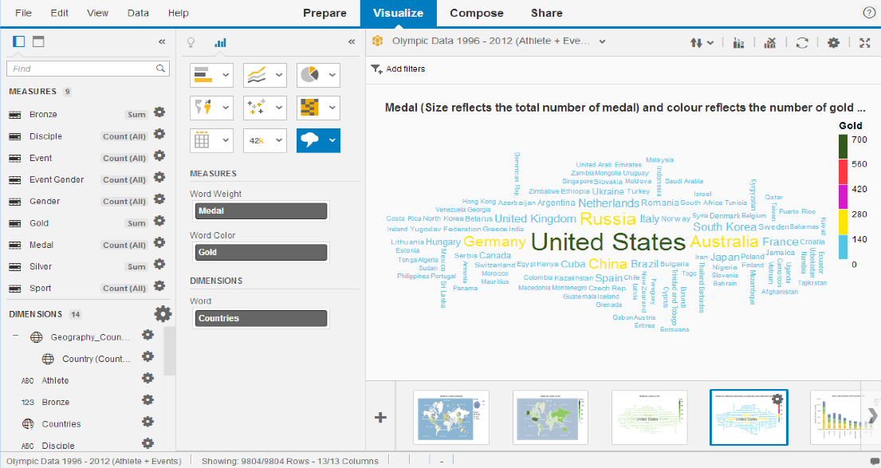

1. *Click ok.*

Now you can see that United States had achieved the most number of medals in year 2012.

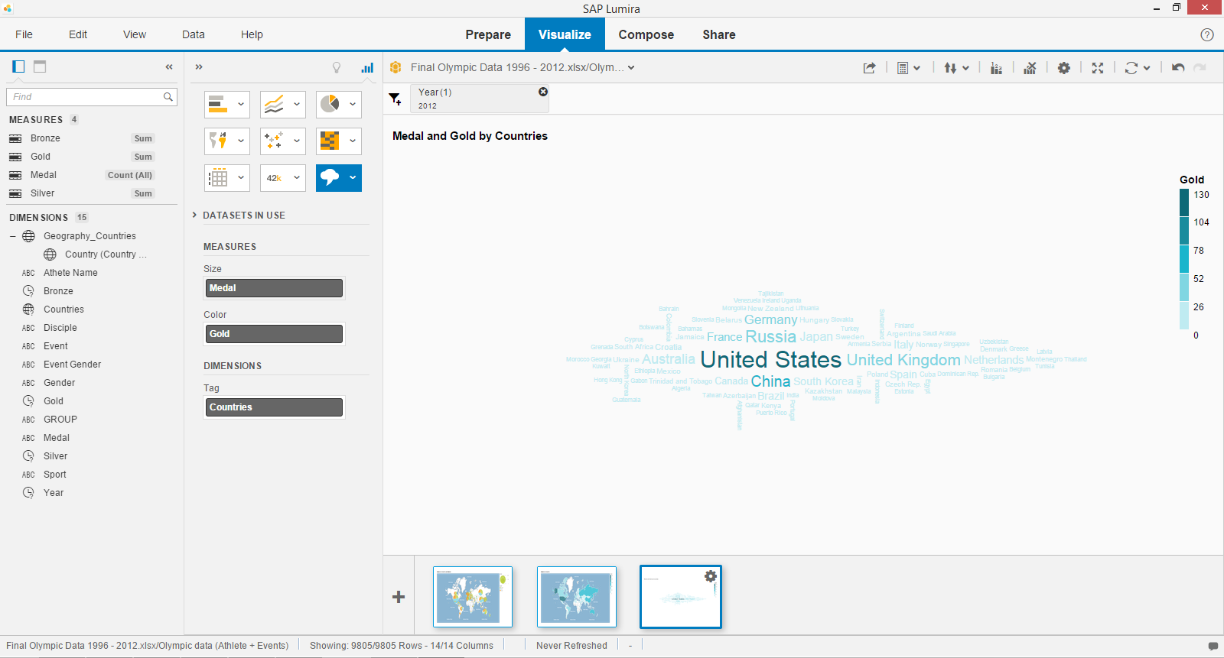

1. Save the document.

### Create visualizations to display Bronze, Silver, Gold by Top 10 Countries in 2012

***Let’s create a visualization to display position of medals by Top 10 Countries in year 2012.***

1. Create a new visualization by clicking.
2. Change the chart type to **Stacked Column charts**.
3. Double-click *Bronze, Silver, and Gold* in *MEASURES* to add a measure (Y-axis).
4. Double-click *Countries* in *DIMENSIONS* to add a dimension (X-axis).
5. Select add filter and choose *year* and 2012.

Now you can see the amount of medals won by different countries in year 2012.

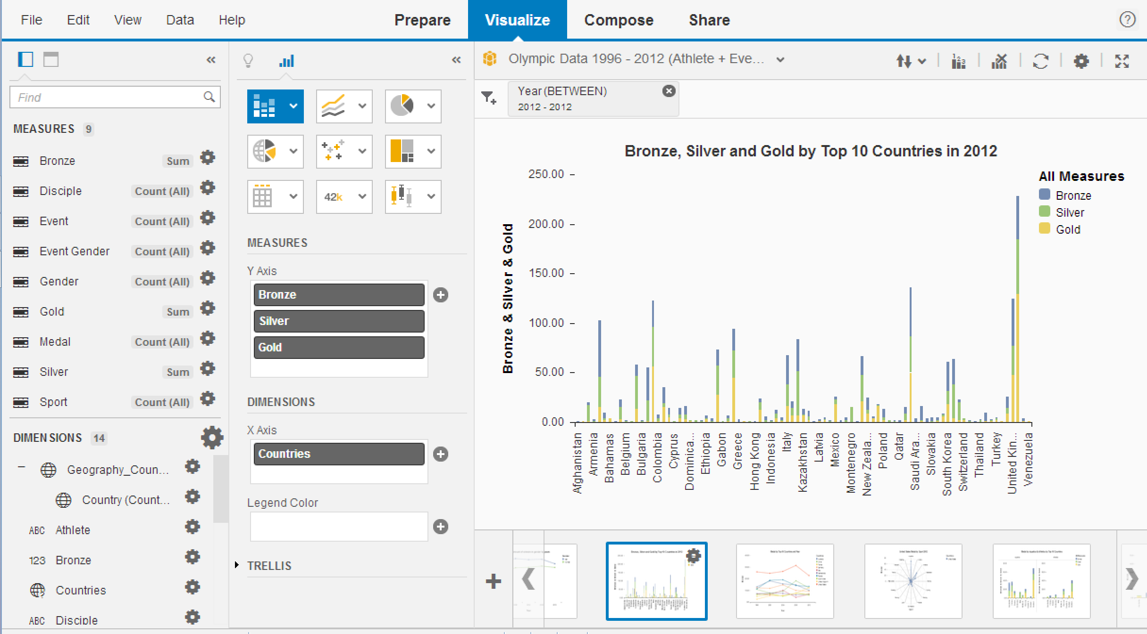

***Focusing on the top 10 countries, filter for the top 10 countries.***

1. Select add filter and choose top 10 *countries* that have the most amount of medals. Click ok. Save the document.

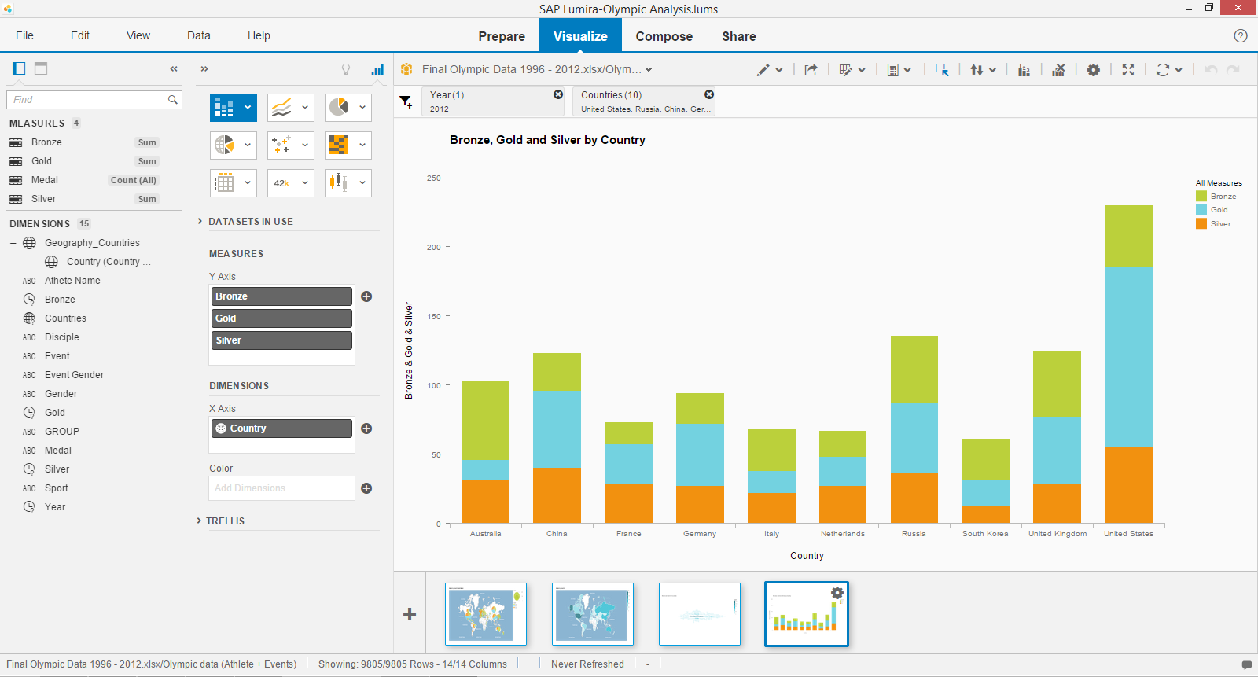Now you can see the **Top 10 Countries** arranged by **bronze, silver and gold in 2012.**

Q1. Which are the top 5 countries in Olympics 2012 – by total number of medals won?

### 4.6 Create visualizations to display Medal by Top 10 Countries and Year

***Next, let’s create a visualization to display Medals by top 10 countries and year to analyze whether there are any incremental trends.***

1. Change the chart type to Line chart.
2. Double-click *Medal* in *MEASURES* to add a measure (Y-axis).
3. Double- click *Year* in *DIMENSIONS* to add a dimension (X-axis) and also double-click *Countries* in *DIMENSIONS* to add a dimension (Legend color)*.*
4. Select add filter and choose Top 10 *countries.* Click ok. Save the document.
5. Now you can see the performance of top 10 countries and analyze the trend.

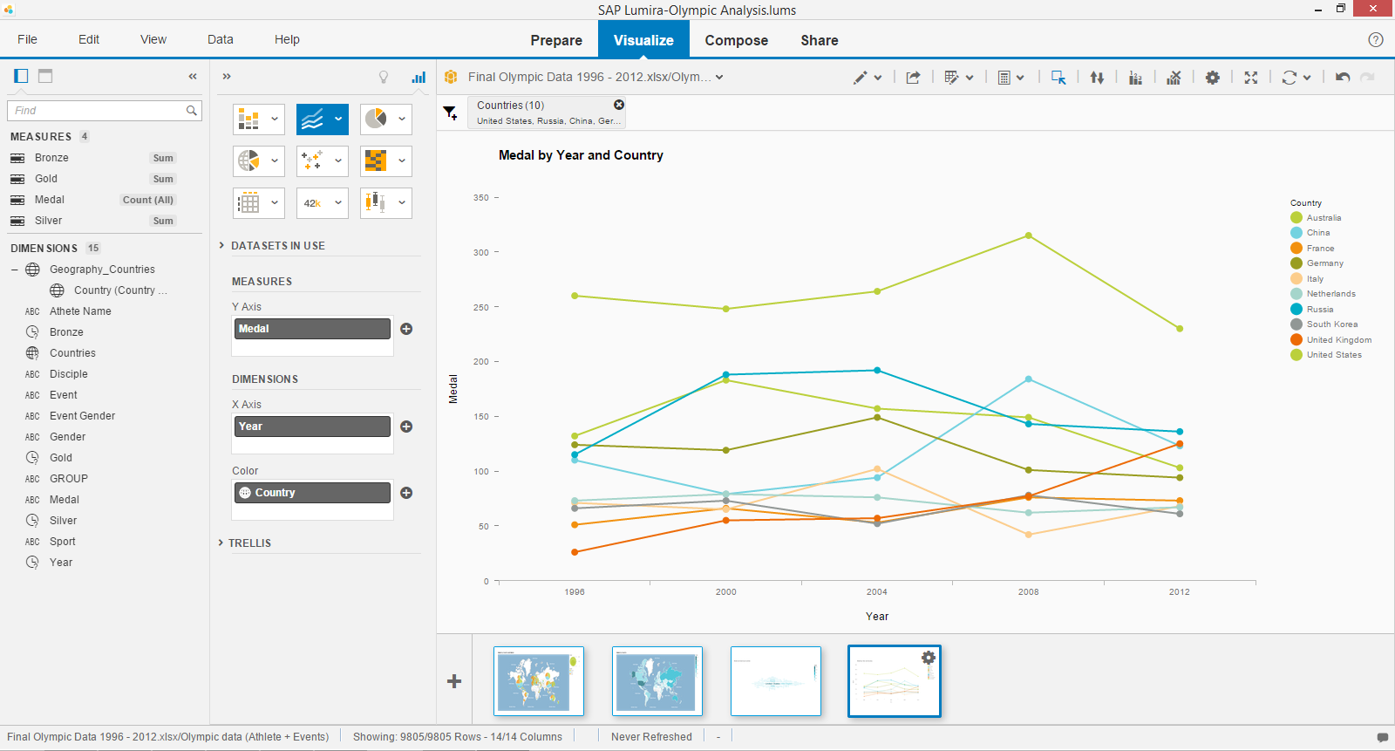

Q2. Compare the performance of China and Australia over the last 5 Olympics.

### 4.7 Create visualizations to display the total amount of winners in gender by years

***Next, let’s create a visualization to display amount of winners by gender over the years.***

1. Change the chart type to Line charts.
2. Create a MEASURE for Gender
3. Double-click *Gender* in *MEASURES* to add a measure (Y-axis).
4. Double-click *Year* in *DIMENSIONS* to add a dimension(X-axis) and also double-click *Gender* in *DIMENSIONS* to add a dimension(Legend Color)

Now you can see the total amount of winners in gender by years.

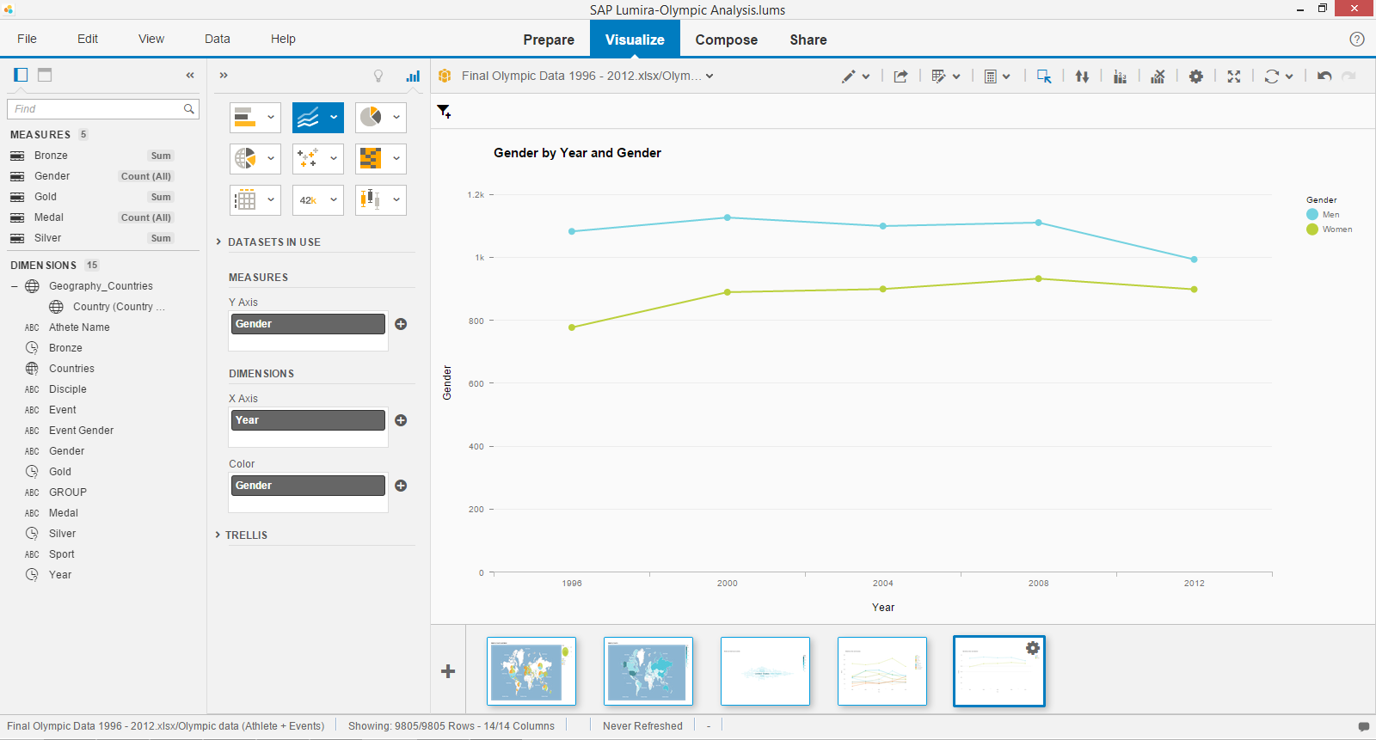

1. Save the document.

Q3. What are the numbers of winners by gender over the last 5 Olympics?

### 4.8 Create visualizations to display Medal by Aquatics & Athletics by Top 10 Countries

***Next, let’s create a visualization to analyze on Medal by the sport (Aquatics & Athletics) by Top 10 Countries.***

1. Change the chart type to Stacked Column Chart.
2. Double-click *Bronze, Silver and Gold* in *MEASURES* to add a measure (Y-axis).
3. Double –click *Countries* in *DIMENSIONS* to add a dimension (X-axis) and drag *Sport* to *TRELLIS 🡪 Columns*.
4. Select add filters and choose *year* and 2012.
5. Select add filters and choose Sports and select Aquatics and Athletics.
6. Select add filters and choose top 10 *Countries.*
7. Save the document.

Now you can see the chart is organized into Aquatics and Athletics (Sport) by Top 10 Countries.

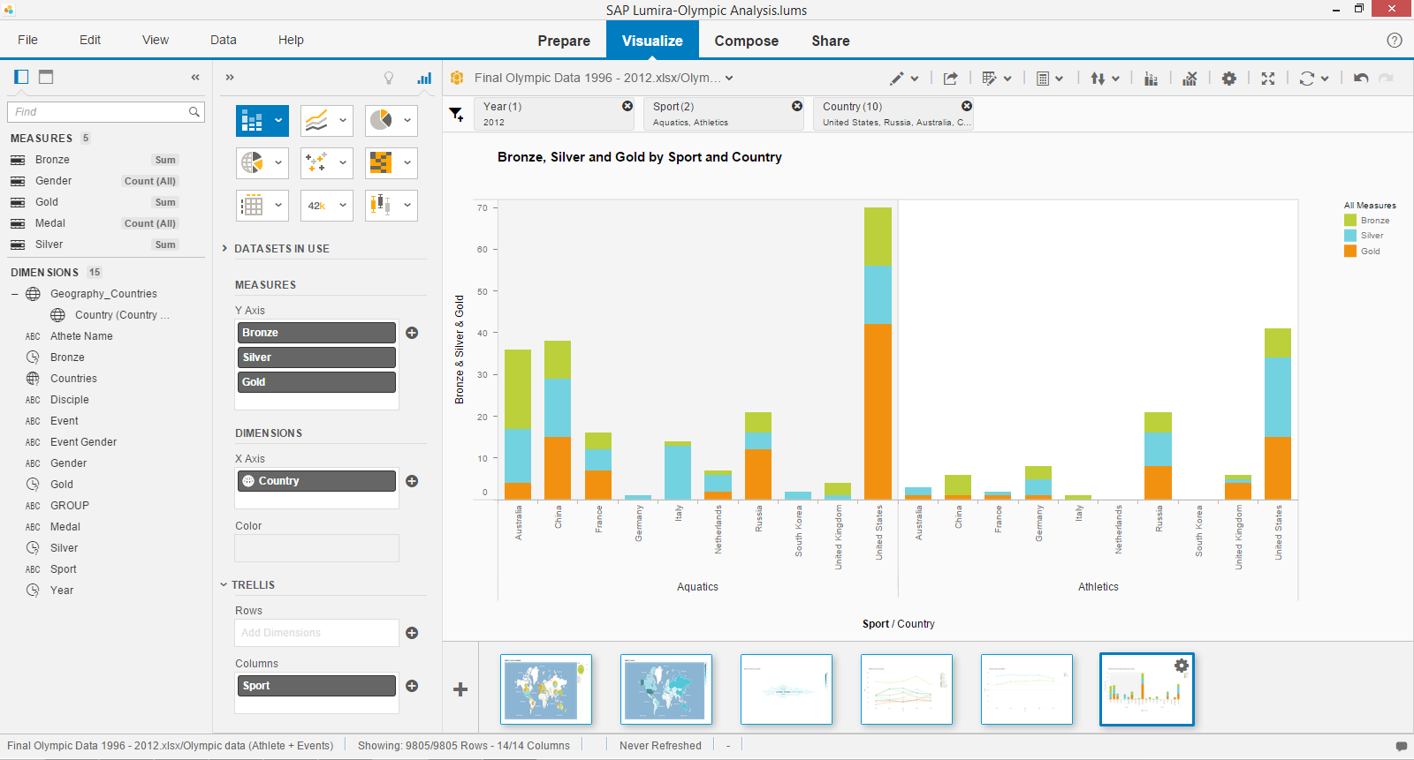

Q4. How did France fare in the sport of Aquatics and Athletics in 2008?

### 4.9 Create visualizations to display Medal by Athlete

***Lastly, let’s create a visualization to analyze who are the potential athletes who won the most medals.***

1. Change the chart type to tree map (due to data constraint) .
2. Double-click *Medal* in *MEASURES* to add a measure in Area Weight (Size).
3. Double-click *Athlete* in *DIMENSIONS* to add a dimension in Area Name.

You will see that data for medal by athlete is too much. Thus, Filtering will take place.

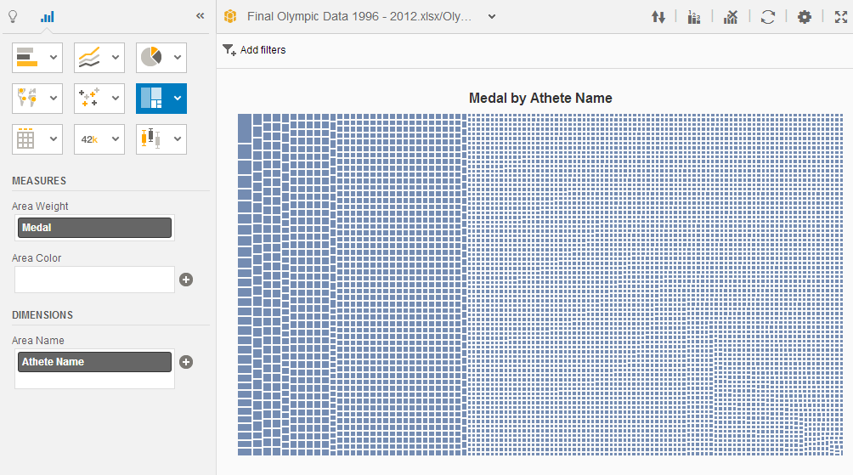

1. Highlight the larger boxes as shown. You can see that Athlete Name is scaled down to 28.

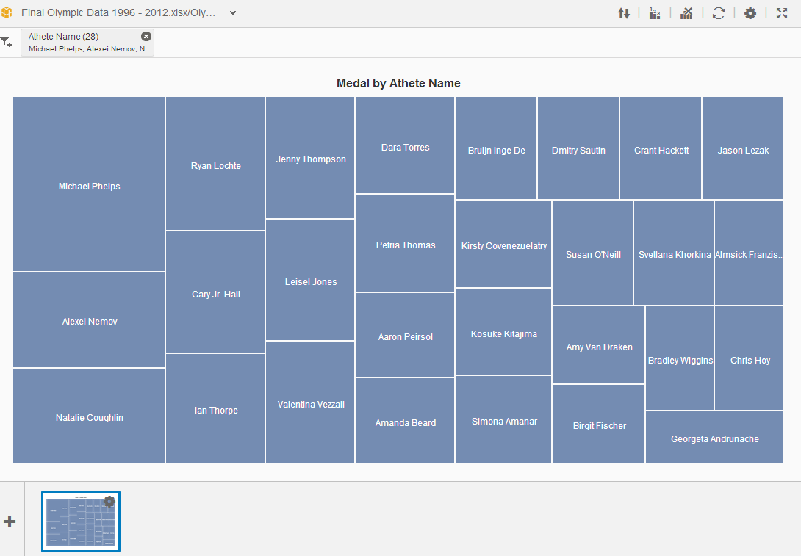

1. However, there is too much data, we will further drill down to 9 Athletes.

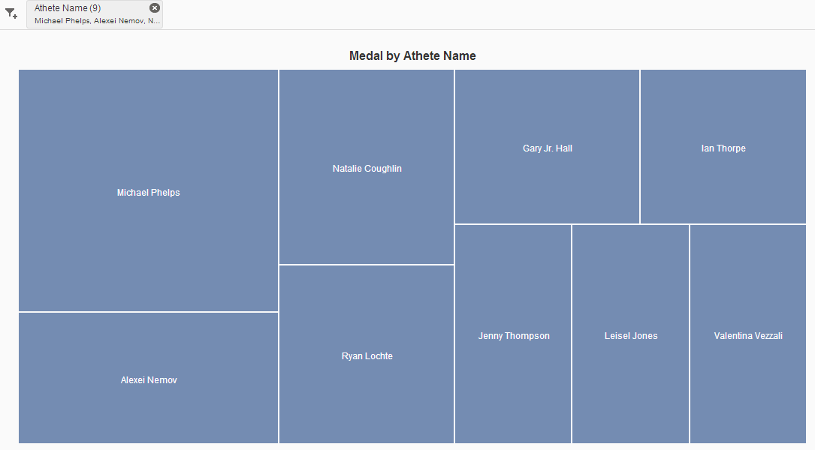

1. Change the chart type to ***heat map***.
2. 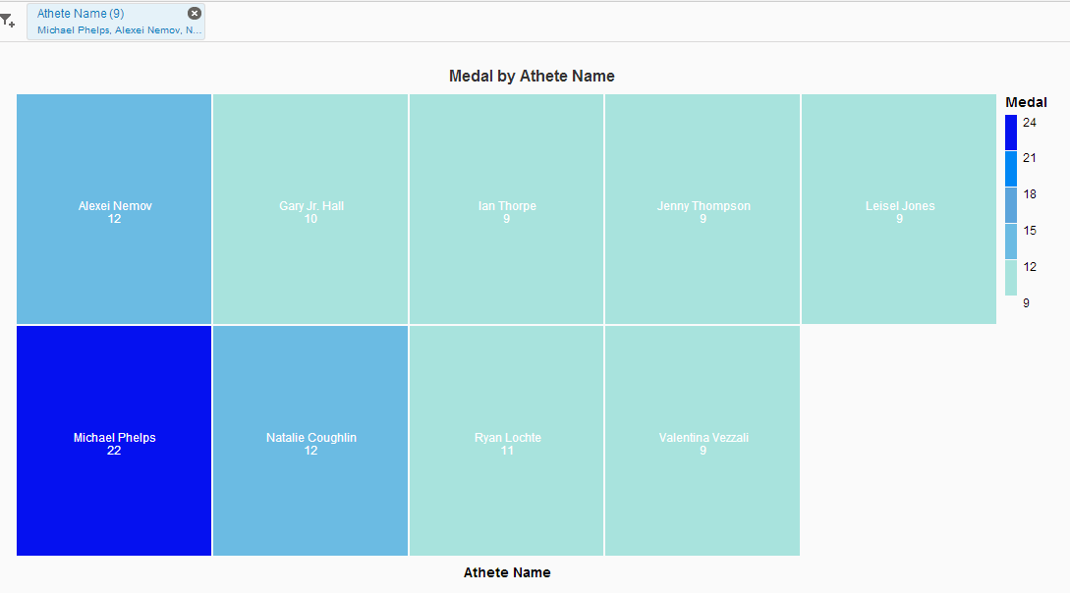In addition, to make **further enhancement** for the chart, user may select from the *settings* icon toshow data labels and also choose the legend item colors to change the color.

You can see **that Michael Phelps had won the most number of medals**.

Q5. In which year(s) did Michael Phelps participate in and how many medals did he win?

## **Adding visualizations into infographic**

1. Select **Compose** and choose detailed.

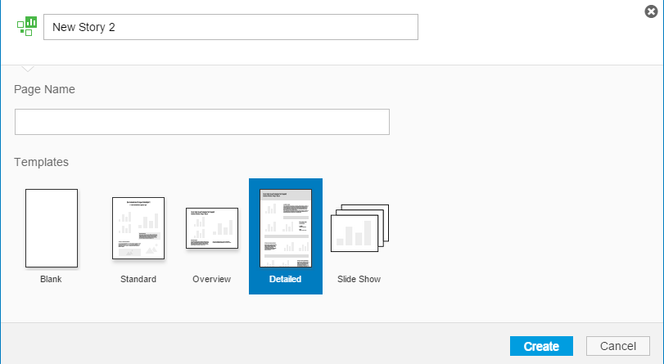

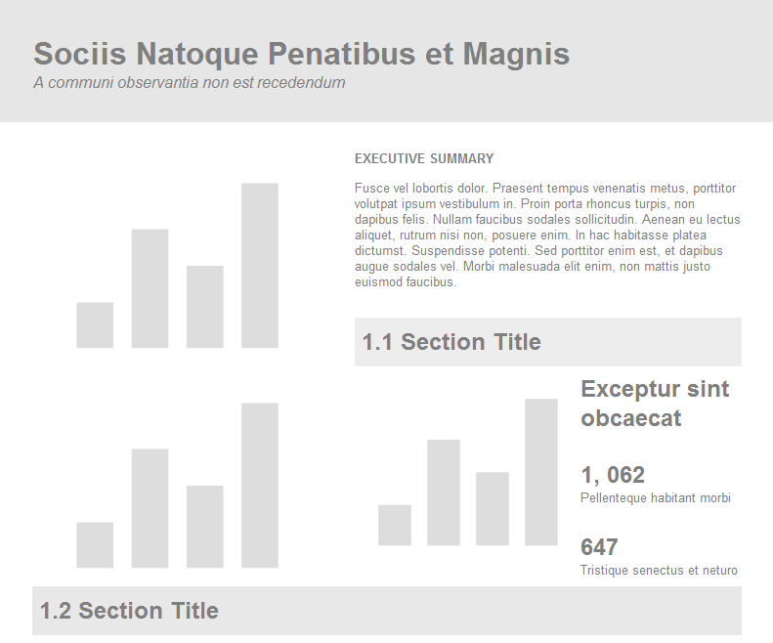

1. To add Pictures and click and select import from local to upload images.

Now you can see that images were being uploaded.

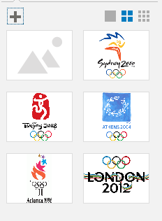

1. Drag images into template.

Now you can see that the section header is filled with the images imported.



1. To add visualizations into template, select visualizations and drag it into template. (Applies to shapes, pictograms and text as well.)

Now you can see an example of compose story in infographic.

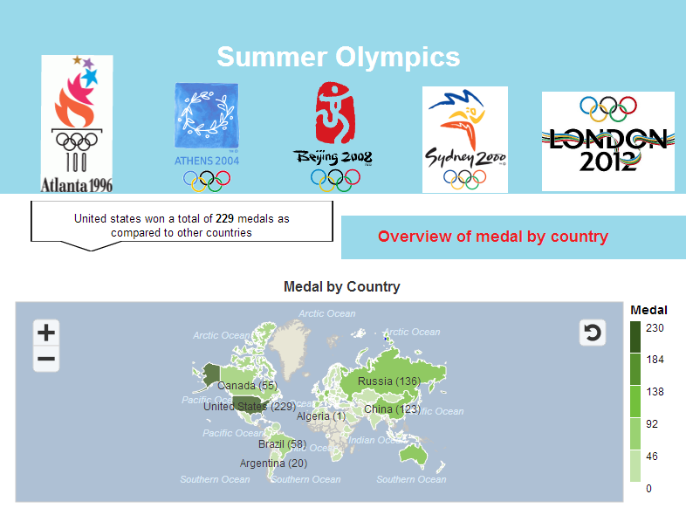

# 

# 5. Case Study 3: Household Electricity

## **5.1 Compose story of Household Electricity Consumption by dwelling type**

It is important to understand the story behind the visualization created. Now, try to create visualizations using the Household Electricity dataset and understand the meaning behind the charts.

Here are some of the samples:

1. Understanding the distribution of energy consumption based on Sector.

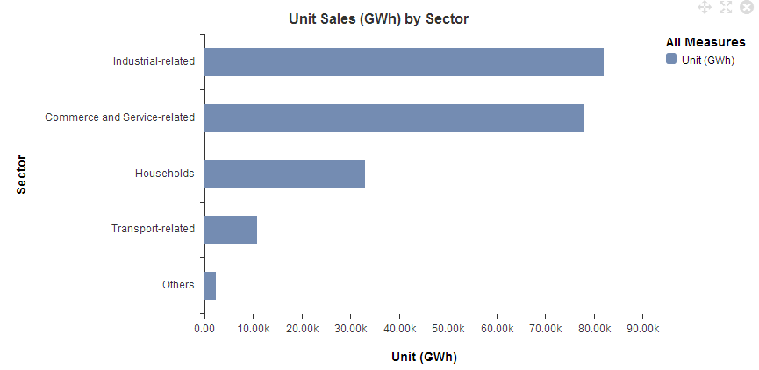We see that the Industrial, Commerce and Service-related sectors consumed the highest amount of electricity.

1. Understanding the top 2 highest energy consumption Sectors.

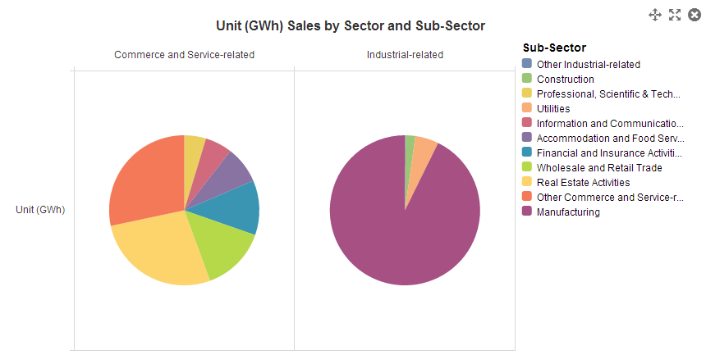

Manufacturing is the single highest consumer in the Industrial sector while Real Estate Activities consumed more than 25% in the Commerce and Service-related sector.

1. Understanding the Energy consumption based on Dwelling type

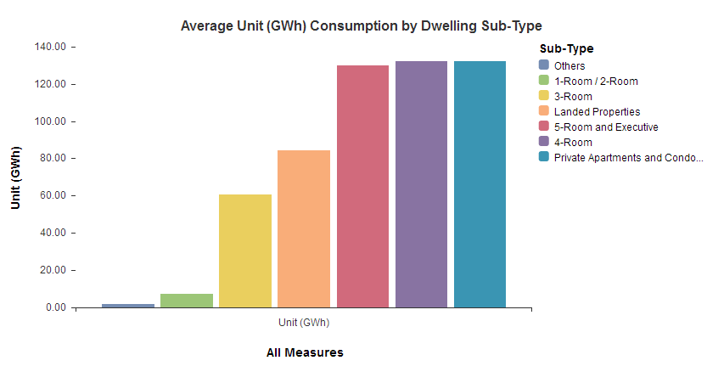

By Dwelling Type, the top 3 consumers were those from Private Apartments and Condominiums, 5-Room and Executive and 4-Room.

1. Analysing the relationship and distribution of energy consumption based on dwelling type.

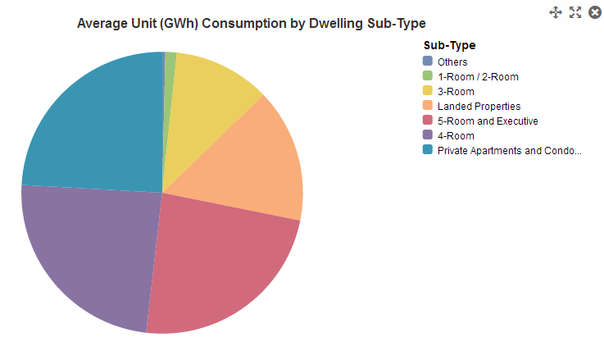

These 3 consumes almost 75% of all household consumption.

1. Understanding how the 3 highest consumption dwelling type has changed over the years.

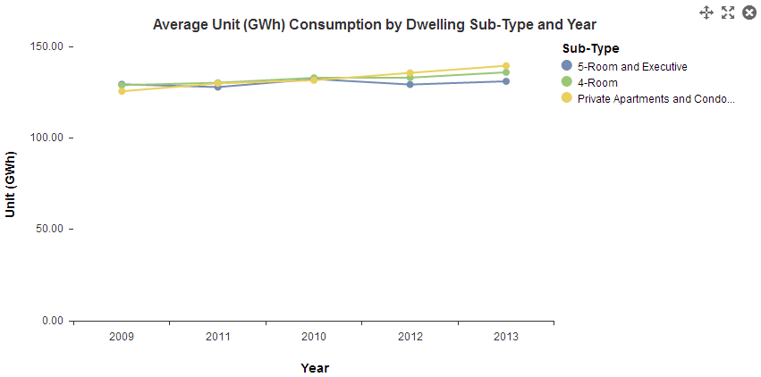

Electricity consumption for these 3 is increasing steadily over the years.

1. Analysing each region average unit of consumption.

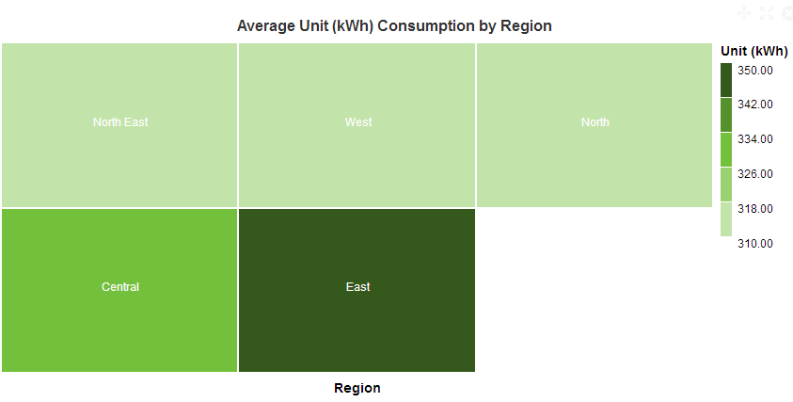

By Region, the households in the East and Central regions are the top consumers.

1. Analysing each region of average unit by planning area.

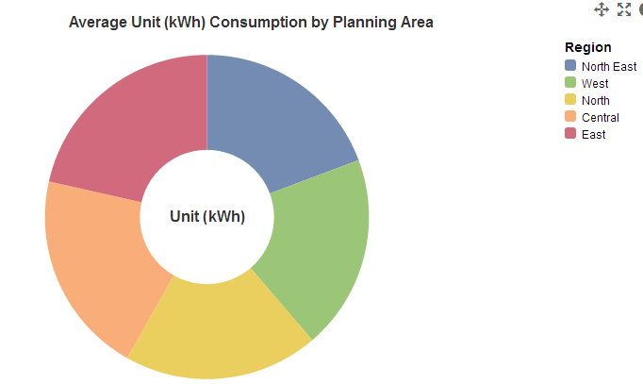

But the different regions consume approximately the same amount of electricity.

1. Analysing the consumption of electricity used by sub-type and region.

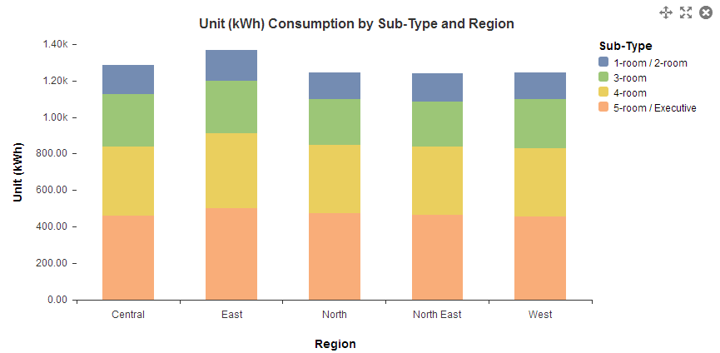And the different households in the different regions consume approximately the same amount of electricity.

# 6. Appendix: Working with the Electricity Consumption Data

With big datasets in excel format, you may need to separate the data in a few worksheets. You will be able to learn how to combine datasets that are separated by different workbooks or worksheets.

Also, you will learn how to add more datasets to your lums file.

1. On the *Home* page, click *Acquire Data*.



1. Double-click on *Microsoft Excel*.



1. Locate and open *Electricity Consumption Private 2012.xlsx.*
2. Click *Add* Files (to append data from another file with the same columns).

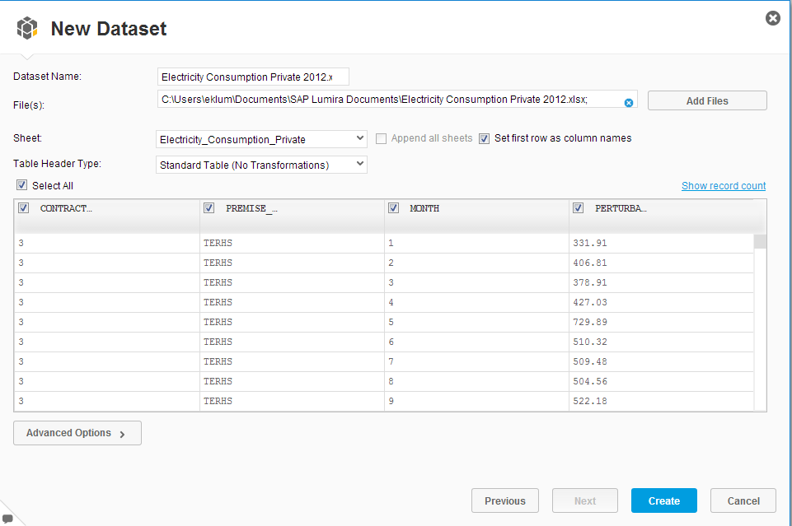

1. Locate and open *Electricity Consumption Public 2012.xlsx.*
2. Click *Create*.

The data is loaded in SAP Lumira and the *Visualize* workspace opens.

Measures are automatically created from dimensions of numerical types; the default aggregation is *Sum*.

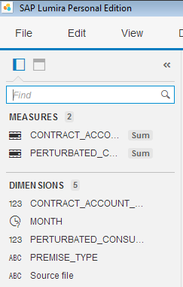

In this case, it is better to use the average consumption rather than the sum for analysis since the sum will be dependent on the count of each premise type. E.g. there will be more 5-room than executive units.

1. Click the *Options* icon beside *PERTURBATED_CONSUMPTION* and select *Change Aggregation 🡪 Average*.

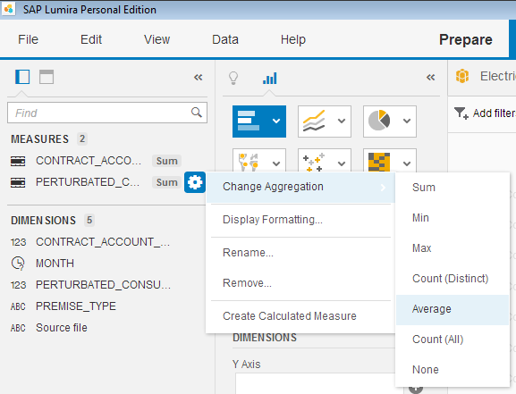

Now, you can acquire more data from another file.

1. Switch to the *Prepare* workspace. Click the dataset drop down list and select *Add Dataset…*

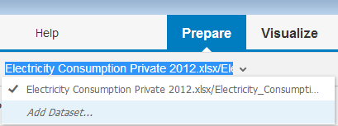

1. Locate and open *Half_Hourly_Electricity_Consumption_2012_08.xlsx.*
2. Click *Create*.

The new dataset is now the active dataset  .

You can switch datasets by clicking the dataset drop down list again to select the desired dataset.

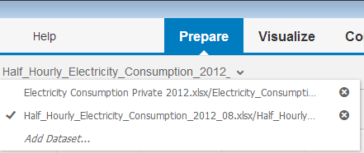

# 7. Resources

## **7.1 SAP Lumira Help Links**

|  |  |
| --- | --- |
| SAP Lumria Resources | <http://help.sap.com/lumira> |
| [Official Product Tutorials](http://scn.sap.com/docs/DOC-26507)  (<http://scn.sap.com/docs/DOC-26507>) |
| <http://scn.sap.com/community/lumira> |
| <http://saplumira.com/learn/tutorials.php> |
| [SAP Lumira Data Samples (http://www.saphana.com/docs/DOC-3934)](http://www.saphana.com/docs/DOC-3934) |

## **7.2 Sample of Data Analytics Challenge**

|  |  |
| --- | --- |
| SAP Lumira University Challenge | <http://saplumira.com/community/university/index.php> |
| Smart Nation - IDA | <http://www.ida.gov.sg/blog/insg/tag/smart-nation/> |
| Data Analytics Challenge for the Professionals | <https://ideas.ecitizen.gov.sg/a/pages/visualisationchallenge-home> |
| SAP Data Geek Challenge | <http://scn.sap.com/docs/DOC-31008> |

## **7.3 Dataset Links**

|  |  |
| --- | --- |
| CIA World Factbook | <https://www.cia.gov/library/publications/the-world-factbook/> |
| UN Data | <http://data.un.org/> |
| UN Data Singapore | <https://data.un.org/CountryProfile.aspx?crName=SINGAPORE> |
| World Bank Data | <http://data.worldbank.org/> |
| Open Data Sites | <http://opendatasites.com/> |
| Global Biodiversity Information Facility | <http://www.gbif.org/> |
| Information is Beautiful | <http://www.informationisbeautiful.net/data/> |
| Quadl | http://quandl.com/ |
| Datahub | http://datahub.io/ |
| Databib | <http://databib.org/> |
| Amazon Datasets | <http://aws.amazon.com/datasets> |
| Datacite | [http://datacite.org](http://datacite.org/) |
| Info Chimps | <http://www.infochimps.com/> |
| SAP Data Geek Challenge - Sample Data sets | <http://scn.sap.com/docs/DOC-31433> |
| Data Gov Singapore | <http://www.data.gov.sg/common/mainsearch.aspx?ag=1> |
| Data Gov | <http://www.data.gov/> |
| Open Government | <http://opengovernmentdata.org/data/> |
| One Map | <http://www.onemap.sg/index.html> |
| Singapore Statistics | <http://www.singstat.gov.sg/statistics/statistics.html> |